**DAILY ONLINE ACTIVITIES SUMMARY**

|  |  |  |  |  |  |  |  |  |
| --- | --- | --- | --- | --- | --- | --- | --- | --- |
| **Date:** | **28th may,2020** | | | | | **Name:** | **Prathusha K A** | |
| **Sem & Sec** | **4th sem &b section** | | | | | **USN:** | **4AL18CS061** | |
| **Online Test Summary** | | | | | | | | |
| **Subject** | | **Aadalitha kannada.** | | | | | | |
| **Max. Marks** | | **50** | | **Score** | | | **20** | |
| **Certification Course Summary** | | | | | | | | |
| **Course** | **Programming for everybody (getting started with python)** | | | | | | | |
| **Certificate Provider** | | | **Coursera** | | **Duration** | | | **7 weeks** |
| **Coding Challenges** | | | | | | | | |
| **Problem Statement: In an array elements contain values from 1 to N with duplicates, the task is to find total number of sub arrays which start and end with the same element.** | | | | | | | | |
| **Status: done** | | | | | | | | |
| **Uploaded the report in Github** | | | | | **yes** | | | |
| **If yes Repository name** | | | | | **https://github.com/prathu47/lockdown-coding** | | | |
| **Uploaded the report in slack** | | | | | **yes** | | | |

Online Test Details: (Attach the snapshot and briefly write the report for the same)

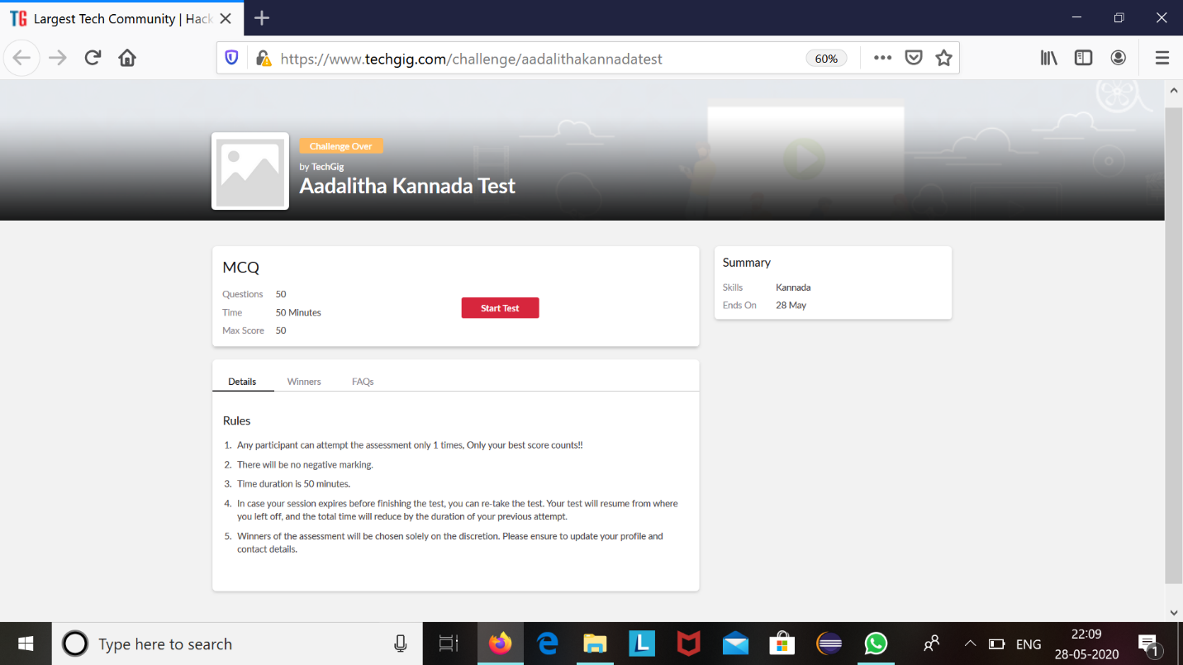

Aadalitha kannada internals was conducted today. A total of 50 questions which is of mcq. Started at 2:00 PM and ended at 2:50 each carries one mark. Its on the topic entire 10 chapters.

The above snapshot is the result sheet which was sent to us by the Techgig team.

Certification Course Details: (Attach the snapshot and briefly write the report for the same)

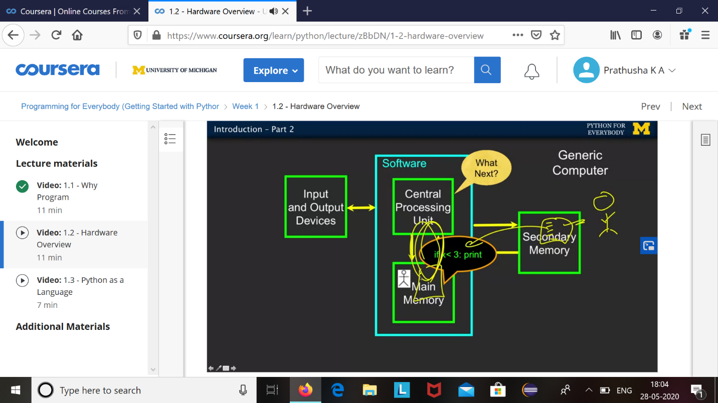

The course I have chosen during the lockdown period is programming for everybody. Since I had previously knew few topics about python iam continuing this course. Since python is gaining a lot of interest in coding platform I have preferred to choose this course.

Coding Challenges Details: (Attach the snapshot and briefly write the report for the same)

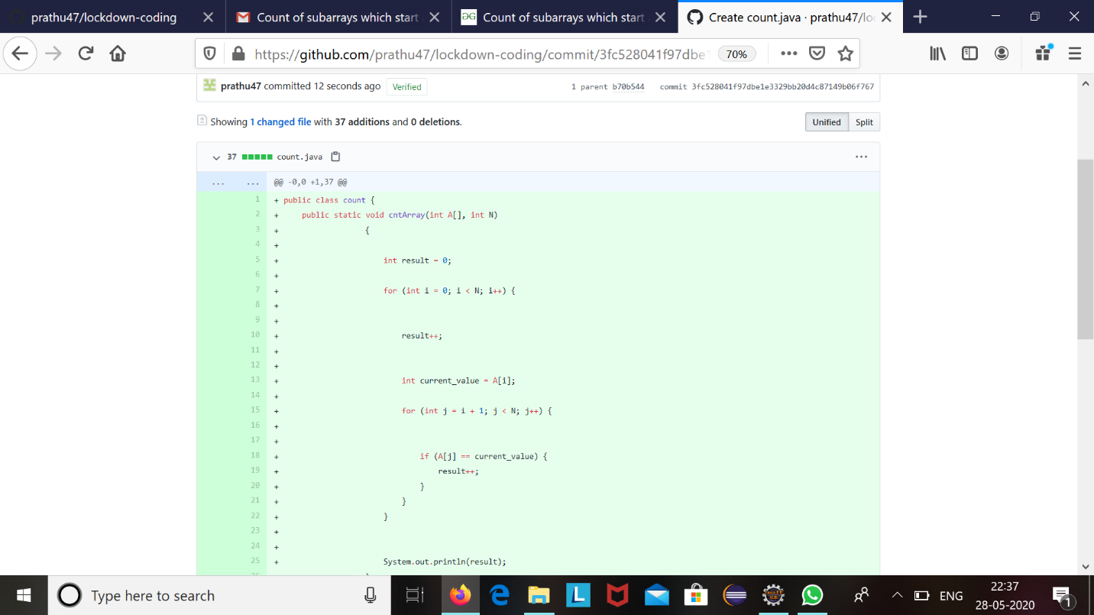

The question we had received today was :

In an array x of size N where the array elements contain values from 1 to N with duplicates,the task is to find total number of sub arrays which start and end with the same element.

Code:The above snapshot is the code which I have uploaded in my github repository.